CO3 – AT3
EVENT DESCRIPTION MATCHER USING FAISS AND CHROMADB
Register Number: 192472364
Name: SALADHI DHARANI
Question No.: 30
Title: Event Description Matcher
Course: CSA6503

1. AIM
To develop a semantic event-matching system for a campus application using sentence embeddings and to benchmark FAISS and ChromaDB for semantic search over more than 200 event descriptions.

2. INTRODUCTION
A campus application can recommend events to students based on their interests. Traditional keyword-based search may fail when the words in the student's query differ from the words used in an event description.
Semantic search solves this problem by converting text into numerical vector representations called embeddings. Texts with similar meanings are represented by vectors that are close to each other in the embedding space.
In this experiment, 245 campus event descriptions were created. The all-MiniLM-L6-v2 sentence-embedding model was used to generate 384-dimensional embeddings. The same embeddings were indexed in both FAISS and ChromaDB.
Ten semantic queries were executed on both databases using Top-5 retrieval. Indexing time, query latency, storage footprint, relevance, and result overlap were measured and compared.

3. PROBLEM STATEMENT
Students may have difficulty finding suitable campus events when their interests do not exactly match the words used in event descriptions.
For example, a student searching for:
cyber security expert speaker
should be able to find an event featuring a cybersecurity researcher even if the event itself belongs to the Technology category.
Therefore, a semantic event-matching system is required to retrieve events based on their meaning rather than exact keyword or category matching.

4. OBJECTIVES
The objectives of this experiment are:
- To create a dataset containing at least 200 event descriptions.
- To generate sentence embeddings using all-MiniLM-L6-v2.
- To use the same embeddings in FAISS and ChromaDB.
- To perform semantic search using at least 10 queries.
- To retrieve the Top-5 results for every query.
- To measure indexing time.
- To measure average query latency.
- To evaluate Top-5 relevance.
- To measure storage footprint.
- To compare Top-5 results from FAISS and ChromaDB.
- To evaluate the special guest-speaker-field query.
- To recommend the more suitable database for the campus application.

5. DATASET DESCRIPTION
A dataset containing 245 event records was generated for the experiment.
Dataset columns
Column | Description
event_id | Unique event identifier
title | Event name
category | Event category
description | Detailed event description
Categories
The dataset contains events related to:
- Artificial Intelligence
- Machine Learning
- Cybersecurity
- Data Science
- Robotics
- Business
- Culture
- Sports
- Leadership
- Technology
- Healthcare
The dataset was saved as:
events.csv
The dataset contains 245 records, which satisfies the required minimum of 200 records.
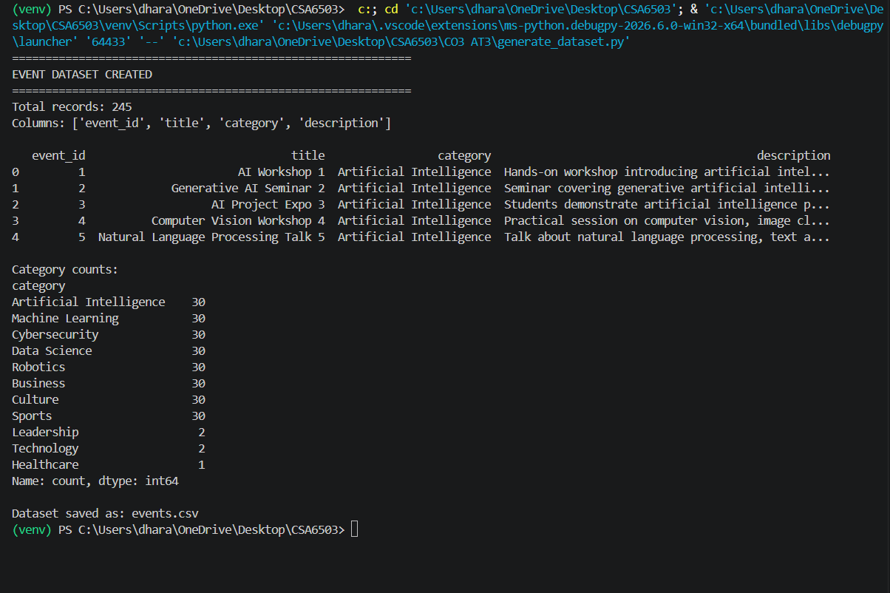Screenshot: generate_dataset.py output
6. TECHNOLOGIES USED
Software
- Python
- Visual Studio Code
- Python Virtual Environment
Libraries
- Pandas
- NumPy
- Sentence Transformers
- FAISS
- ChromaDB
Embedding Model
all-MiniLM-L6-v2
Embedding Dimension
384

7. SYSTEM ARCHITECTURE
The system follows the architecture:

8. METHODOLOGY
The experiment was performed in the following steps:
Step 1 — Dataset Creation
245 event descriptions were generated and stored in events.csv.
Step 2 — Embedding Generation
The all-MiniLM-L6-v2 model converted each event description into a 384-dimensional vector.
Step 3 — FAISS Indexing
The generated embeddings were inserted into a FAISS vector index.
Step 4 — ChromaDB Indexing
The same embeddings were inserted into a persistent ChromaDB collection.
Step 5 — Semantic Search
Ten student-interest queries were executed on both databases.
Step 6 — Benchmarking
The following metrics were measured:
- Indexing time
- Average query latency
- Top-5 relevance
- Storage footprint
- Top-5 overlap
Step 7 — Special Case
A query requiring matching through the guest speaker's professional field was tested.

9. EMBEDDING GENERATION
The Sentence Transformers model:
all-MiniLM-L6-v2
was loaded and used for all event descriptions.
Actual result
Parameter | Result
Number of events | 245
Number of embeddings | 245
Embedding dimension | 384
Embedding shape | (245, 384)
Generation time | 1.0306 seconds
The generated embeddings were saved as:
event_embeddings.npy
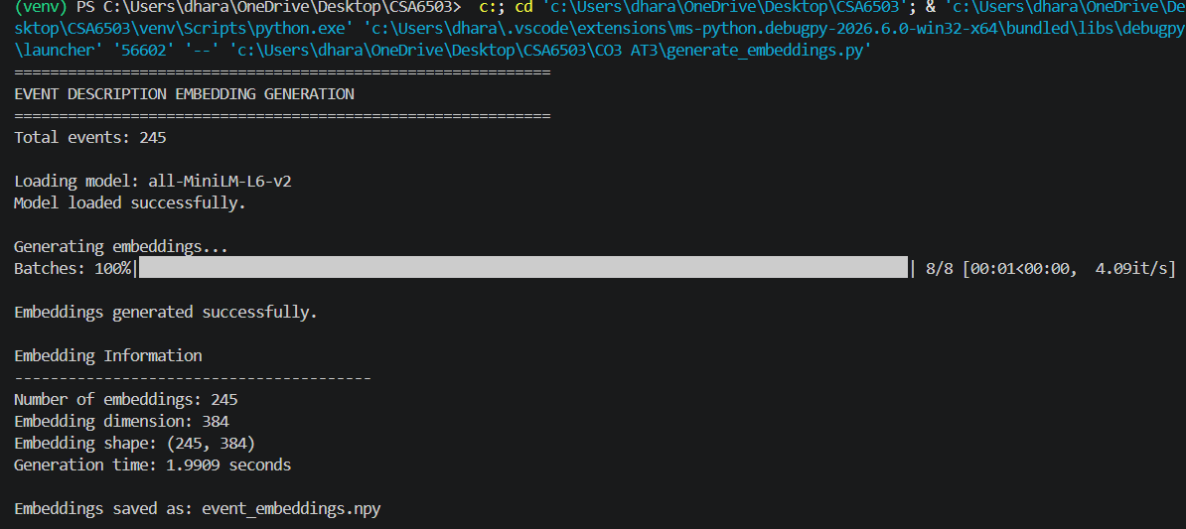
Figure 2: Generation of 384-dimensional event embeddings

10. FAISS INDEXING
The 245 embeddings were indexed using FAISS.
Actual result
Parameter | Result
Number of vectors | 245
Embedding dimension | 384
Indexing time | 0.000213 seconds
FAISS index size | 367.54 KB
The index was saved as:
events_faiss.index
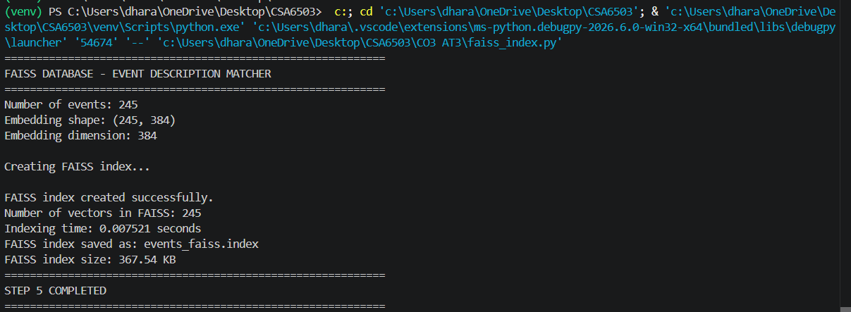
Figure 3: FAISS index creation and storage measurement

11. CHROMADB INDEXING
The same 245 embeddings were inserted into a persistent ChromaDB collection.
Actual result
Parameter | Result
Number of documents | 245
Embedding dimension | 384
Indexing time | 0.161309 seconds
Storage size | 1400.16 KB
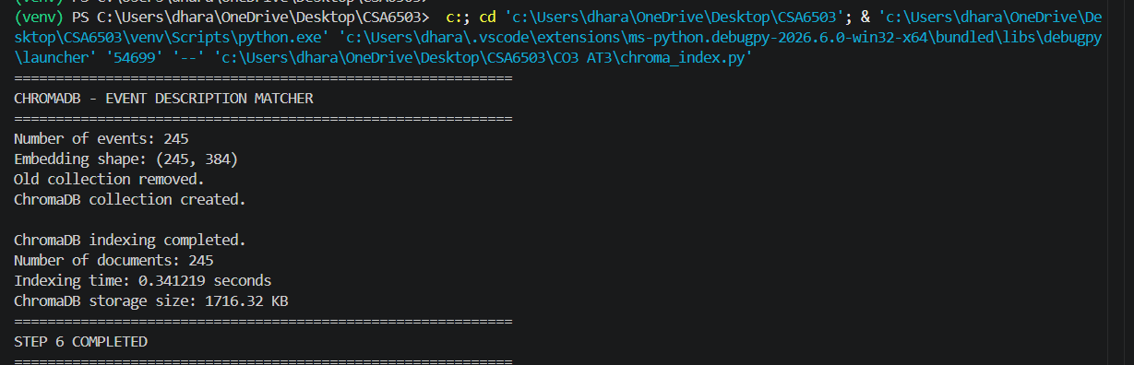
Figure 4: ChromaDB collection creation and storage measurement
12. INITIAL SEMANTIC SEARCH TEST
The first query tested was:
machine learning projects
Both databases returned the same Top-5 events:
Rank | Event ID | Event
1 | 170 | Machine Learning Project Review 170
2 | 10 | Machine Learning Project Review 10
3 | 50 | Machine Learning Project Review 50
4 | 210 | Machine Learning Project Review 210
5 | 90 | Machine Learning Project Review 90
Query latency from initial test
Database | Latency
FAISS | 0.2735 ms
ChromaDB | 52.5986 ms
The later benchmark measured multiple queries and produced the final average values reported below.
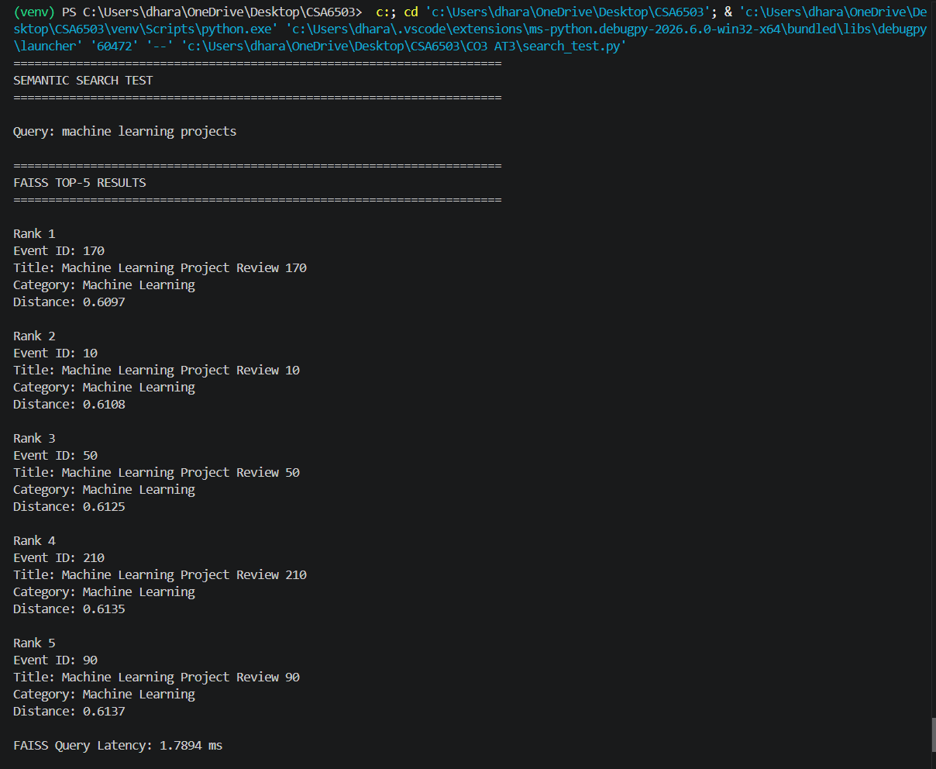
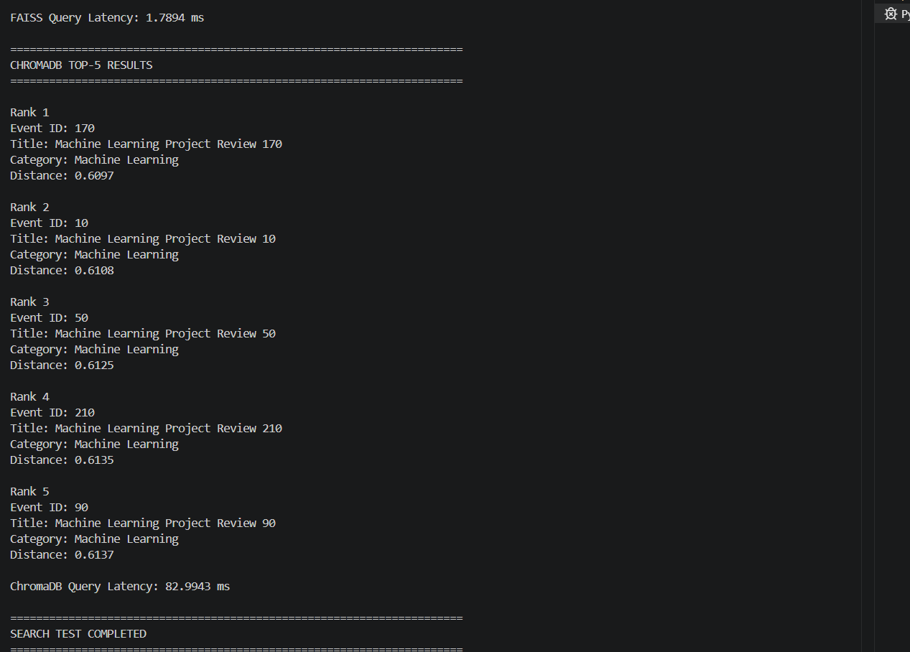
Figure 5: Initial semantic search using FAISS and ChromaDB

13. TEN-QUERY SEMANTIC SEARCH BENCHMARK
The same 10 queries were executed on both databases.
No. | Query | FAISS Latency (ms) | ChromaDB Latency (ms) | Overlap
1 | machine learning projects | 0.1072 | 33.2313 | 5/5
2 | artificial intelligence workshop | 0.1377 | 2.1217 | 5/5
3 | robotics competition | 0.0697 | 1.6547 | 5/5
4 | data analytics training | 0.1359 | 1.7593 | 5/5
5 | startup funding session | 0.1363 | 1.6147 | 5/5
6 | music and dance festival | 0.0687 | 1.8214 | 5/5
7 | football tournament | 0.1365 | 1.6792 | 5/5
8 | cyber security awareness | 0.1580 | 1.6439 | 5/5
9 | leadership development | 0.0699 | 2.0629 | 5/5
10 | cyber security expert speaker | 0.0721 | 1.6449 | 5/5
Average | — | 0.1092 | 4.9234 | 5/5
Observation
FAISS achieved an average query latency of 0.1092 ms, while ChromaDB achieved 4.9234 ms.
Both databases produced the same Top-5 results for all 10 queries.
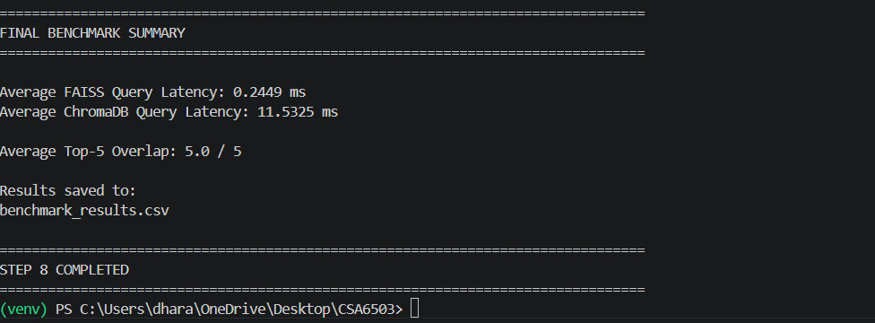

14. TOP-5 RELEVANCE EVALUATION
The semantic relevance of the Top-5 results was evaluated for the ten queries.
Query | FAISS Relevance | ChromaDB Relevance
machine learning projects | 100% | 100%
artificial intelligence workshop | 100% | 100%
robotics competition | 100% | 100%
data analytics training | 100% | 100%
startup funding session | 100% | 100%
music and dance festival | 100% | 100%
football tournament | 100% | 100%
cyber security awareness | 100% | 100%
leadership development | 100% | 100%
cyber security expert speaker* | 80%* | 80%*
Average | 98% | 98%

*The special-case query was evaluated separately because Event 245 belongs to the Technology category but is relevant through its guest speaker's cybersecurity field.
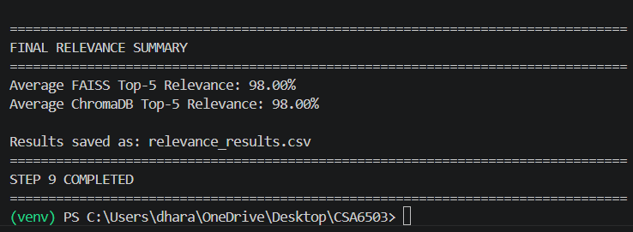
Figure 7: Top-5 relevance evaluation

15. FINAL BENCHMARK SUMMARY
Metric | FAISS | ChromaDB
Dataset records | 245 | 245
Embedding model | all-MiniLM-L6-v2 | all-MiniLM-L6-v2
Embedding dimension | 384 | 384
Indexing time | 0.000213 s | 0.161309 s
Storage footprint | 367.54 KB | 1400.16 KB
Queries tested | 10 | 10
Top-k | 5 | 5
Average query latency | 0.1092 ms | 4.9234 ms
Average Top-5 relevance | 98% | 98%
Average Top-5 overlap | 5/5 | 5/5
Analysis
FAISS showed considerably lower measured indexing time and query latency than ChromaDB.
The measured storage footprint of FAISS was also smaller.
However, both databases produced the same search results because the same embeddings and queries were used.

16. TOP-5 COMPARISON — QUERY 1
Query
machine learning projects
Rank | FAISS | ChromaDB
1 | 170 | 170
2 | 10 | 10
3 | 50 | 50
4 | 210 | 210
5 | 90 | 90
Overlap: 5/5
Result order: Identical
FAISS-only: None
ChromaDB-only: None

17. TOP-5 COMPARISON — QUERY 2
Query
music and dance festival
Rank | FAISS | ChromaDB
1 | 193 | 193
2 | 232 | 232
3 | 152 | 152
4 | 72 | 72
5 | 32 | 32
Overlap: 5/5
Result order: Identical
FAISS-only: None
ChromaDB-only: None

18. TOP-5 COMPARISON — QUERY 3
Query
cyber security expert speaker
Rank | FAISS | ChromaDB
1 | 245 | 245
2 | 171 | 171
3 | 51 | 51
4 | 131 | 131
5 | 11 | 11
Overlap: 5/5
Result order: Identical
FAISS-only: None
ChromaDB-only: None
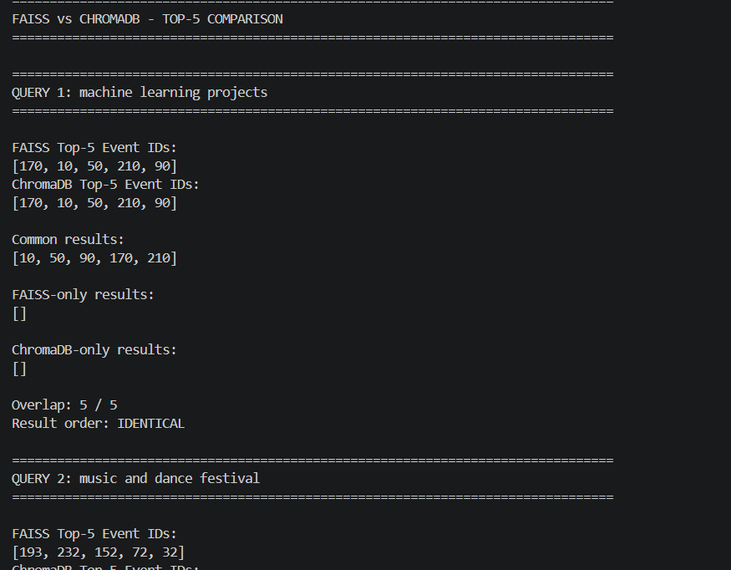
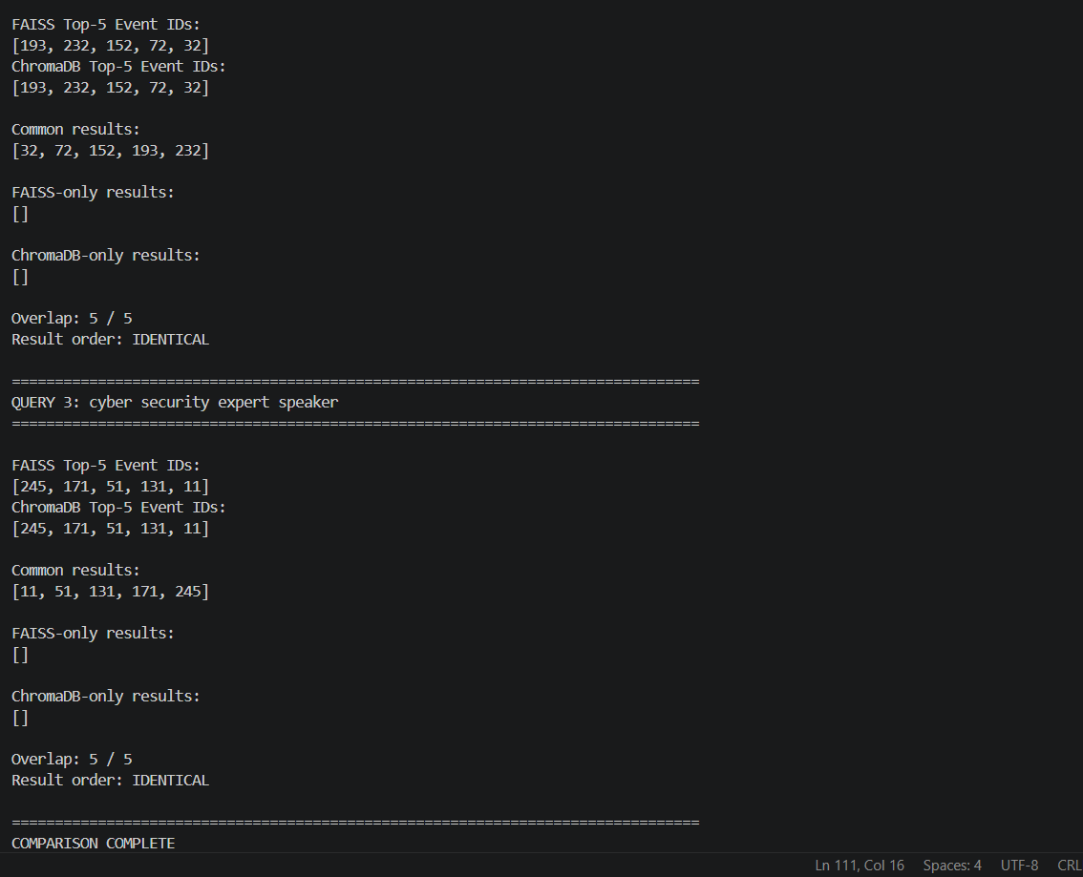 Figure 9: Top-5 result comparison between FAISS and ChromaDB
19. TOP-5 COMPARISON ANALYSIS
For all three selected queries, FAISS and ChromaDB returned exactly the same five event IDs in exactly the same order.
Query | Overlap | Order
Machine learning projects | 5/5 | Identical
Music and dance festival | 5/5 | Identical
Cyber security expert speaker | 5/5 | Identical
There were no FAISS-only or ChromaDB-only results.
This occurred because both systems used:
- The same dataset
- The same embedding model
- The same 384-dimensional embeddings
- The same query embeddings
- The same Top-5 search requirement
Therefore, the experiment demonstrates that both databases can provide equivalent retrieval results for this dataset, while their performance characteristics differ.

20. SPECIAL-CASE QUERY
Required special case
An interest query matching an event only through its guest speaker's field.
Query
cyber security expert speaker
FAISS result
Rank 1
Event ID: 245
Title: Digital Trust Conference
Category: Technology
ChromaDB result
Rank 1
Event ID: 245
Title: Digital Trust Conference
Category: Technology
Event description
Conference featuring Dr. Ravi Kumar, a cybersecurity researcher. The program discusses digital transformation, technology leadership, and professional development.
Why is this event relevant?
The student's query asks for a cybersecurity expert speaker.
The event itself belongs to the Technology category. However, the event description states that Dr. Ravi Kumar is a cybersecurity researcher.
Therefore, the semantic match occurs through the guest speaker's professional field, rather than through the event category.
This demonstrates that sentence embeddings can identify semantic relationships within event descriptions even when the main category does not directly match the query.
Special-case result
Database | Rank | Event | Category | Reason
FAISS | 1 | Digital Trust Conference | Technology | Guest speaker is a cybersecurity researcher
ChromaDB | 1 | Digital Trust Conference | Technology | Guest speaker is a cybersecurity researcher
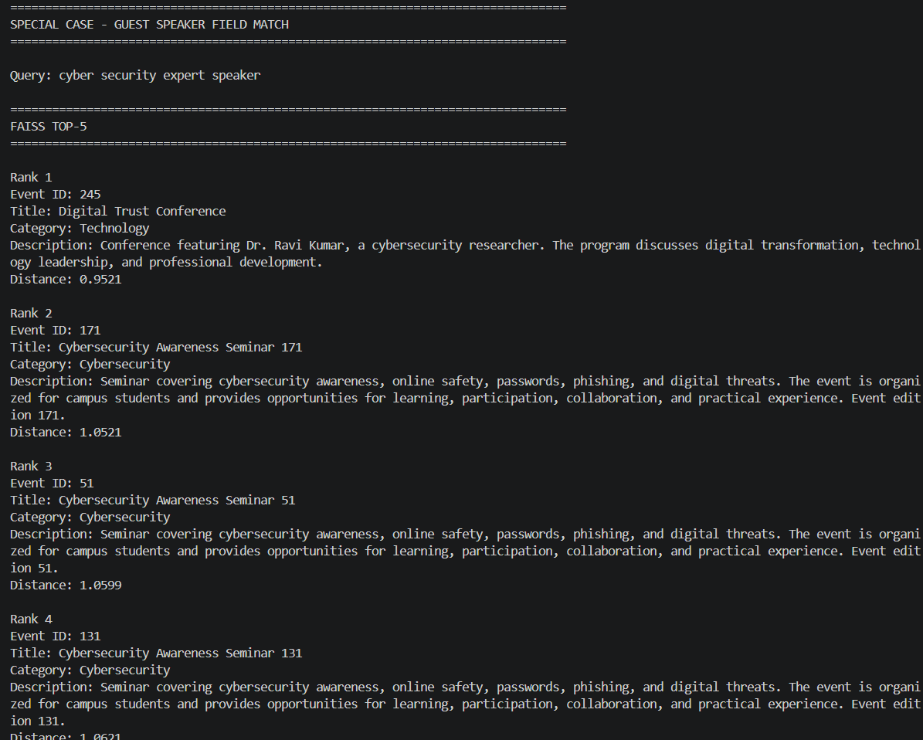
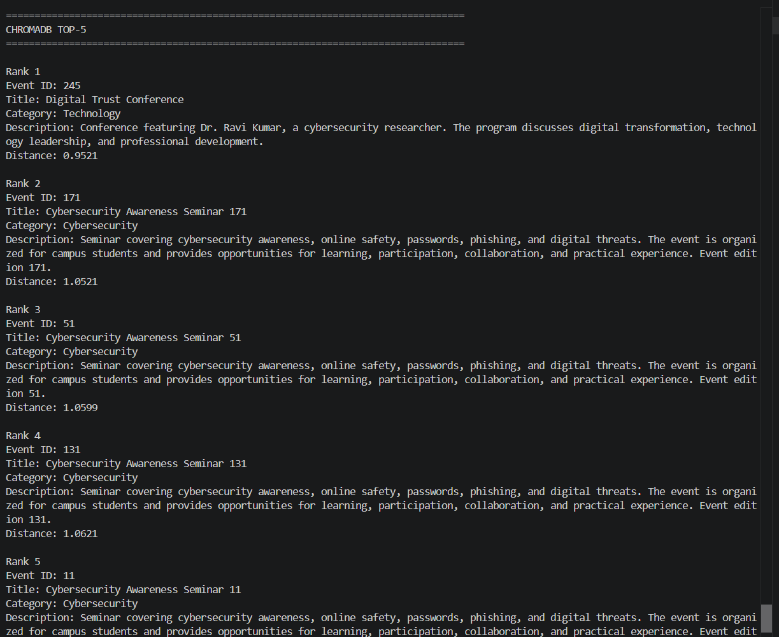
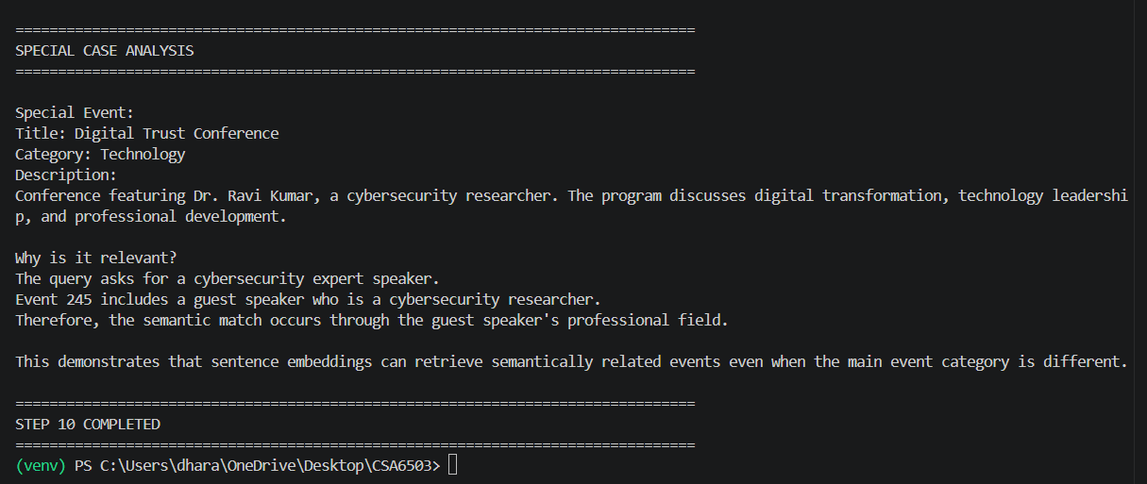
Figure 8: Special-case semantic match through the guest speaker's field21. STORAGE
COMPARISON
Database | Storage
FAISS | 367.54 KB
ChromaDB | 1400.16 KB
FAISS used the smaller measured storage footprint in this experiment.
The difference can be attributed to the additional persistent database structures and metadata maintained by ChromaDB.

22. PERFORMANCE ANALYSIS
FAISS
FAISS achieved:
Indexing time: 0.000213 seconds
Average query latency: 0.1092 ms
Storage: 367.54 KB
FAISS is therefore highly suitable when the application prioritizes fast vector retrieval.
ChromaDB
ChromaDB achieved:
Indexing time: 0.161309 seconds
Average query latency: 4.9234 ms
Storage: 1400.16 KB
Although slower in this experiment, ChromaDB provides a persistent vector-database-oriented approach that can be useful when database and metadata management are important.

23. FAISS VS CHROMADB
Feature | FAISS | ChromaDB
Search speed | Very fast | Slower in this test
Indexing speed | Faster | Slower
Storage | Lower measured footprint | Higher measured footprint
Semantic quality | Same | Same
Persistence | Index file | Persistent collection
Metadata/database management | More application-managed | More database-oriented
Suitable for | High-speed vector search | Persistent vector applications
Result overlap | 5/5 | 5/5

24. RECOMMENDATION
For the campus Event Description Matcher, FAISS is recommended when the primary requirement is fast semantic retrieval from a relatively fixed collection of event descriptions.
The experiment showed:
- Much lower average query latency
- Faster indexing
- Lower measured storage footprint
- Same Top-5 retrieval results
- Same average relevance
Therefore, FAISS provides excellent performance for this particular use case.
When should ChromaDB be preferred?
ChromaDB would be preferable when the application requires more database-oriented functionality such as:
- Persistent collections
- Metadata management
- Easier document and vector management
- Frequent additions or updates to the collection
- A more complete vector-database workflow
Thus, the choice depends on application requirements rather than retrieval quality alone.

25. LIMITATIONS
The experiment was conducted on a dataset of 245 generated event descriptions. Therefore, the benchmark represents a relatively small campus-event collection.
The measured latency and storage values depend on the hardware, software environment, database configuration, and system load.
The Top-5 relevance evaluation was based on the relevance criteria defined for this experiment.

26. CONCLUSION
The Event Description Matcher was successfully developed using sentence embeddings and two vector-search databases, FAISS and ChromaDB.
A dataset containing 245 event descriptions was created and converted into 384-dimensional embeddings using all-MiniLM-L6-v2. The same embeddings were indexed in both databases.
Ten semantic queries were executed and compared. Both databases produced identical Top-5 results with an average overlap of 5/5 and an average Top-5 relevance of 98%.
FAISS achieved an average query latency of 0.1092 ms, while ChromaDB achieved 4.9234 ms. FAISS also had a lower measured storage footprint and faster indexing time.
The special-case query, cyber security expert speaker, successfully retrieved the Digital Trust Conference because its description mentions a guest speaker who is a cybersecurity researcher, even though the event belongs to the Technology category.
Hence, FAISS is recommended for this campus application when speed and efficient vector retrieval are the primary requirements, while ChromaDB is preferable when persistent vector-database and metadata-management capabilities are more important.

